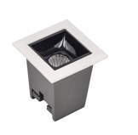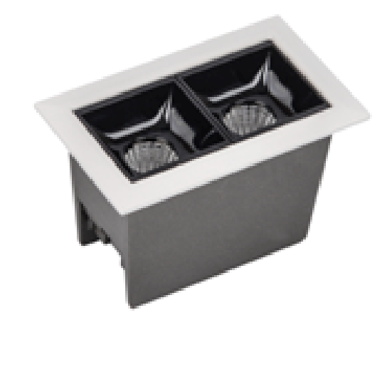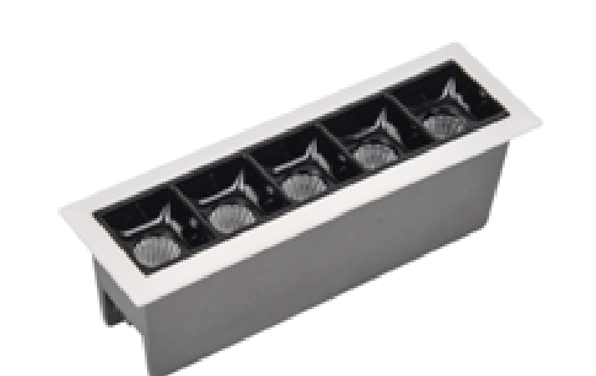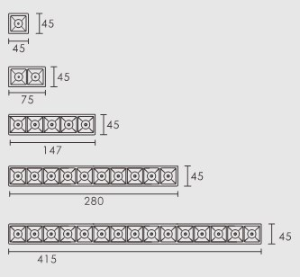
Derrywood Agencies Email: sales@derrywood.com
Unit 4, Naas Road Business Park Email: clarederrywoodagencies@gmail.com
Muirfield Drive, Naas road, Dublin 12 Phone: 086 2594661 / 01 4503800
The Ruby X downlight is a complete range of recessed
LED lighting from Intelux. We offer the X1, X2 and X5 way
lighting system with alternative colour options. The
LED uses the latest technology in the Osram 3030 chip
and is ideal for kitchens, bathrooms, retail and hotel
settings. It comes complete with a 3-year warranty.
Light Source
LED 2 Watts per module
Material
Die Cast Steel
Colour Temperature

Warm white, cool white and white
Beam angle
45
degrees
Colour Rendering Index
CRI >90
Ingres Protection
IP20
Cut out sizes
X1 = 40 *40, X2 = 40 * 70, X5 = 40 * 142 (mm)
Chip
Osram 3030, 50,000 hours

